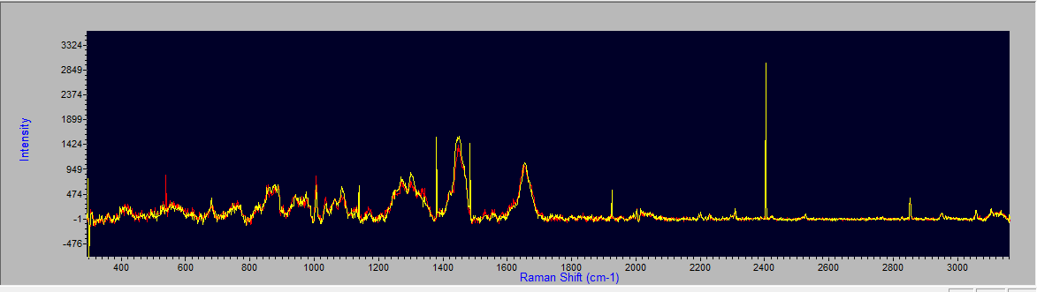

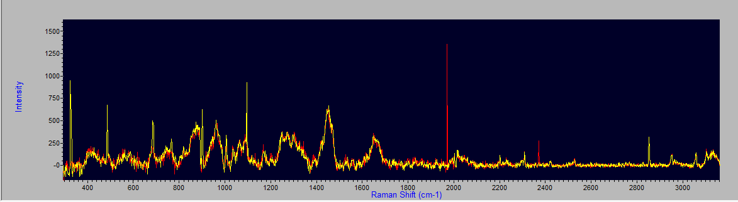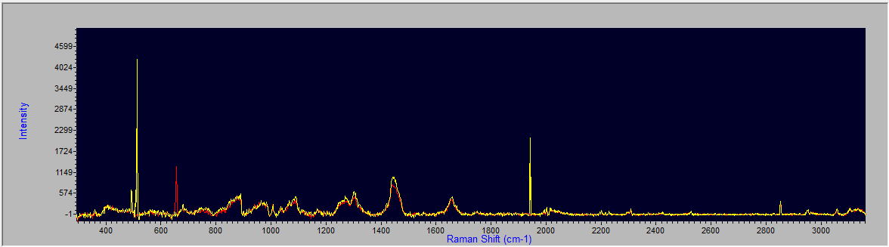

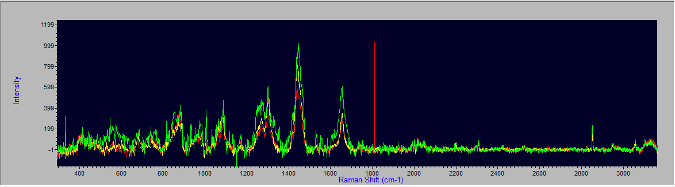

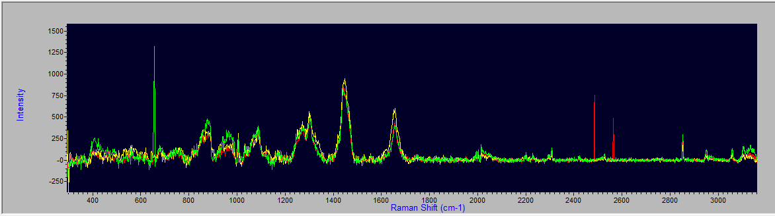

Neg

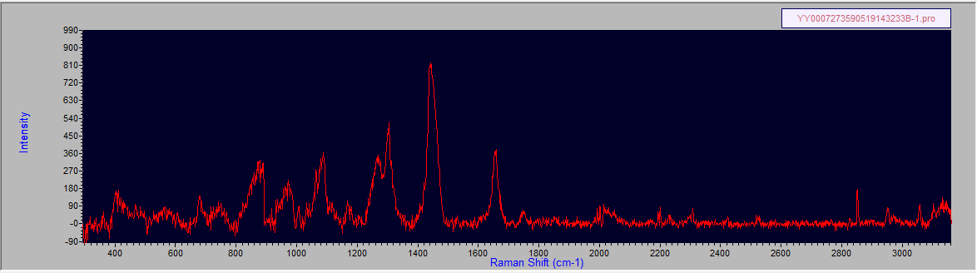

Neg

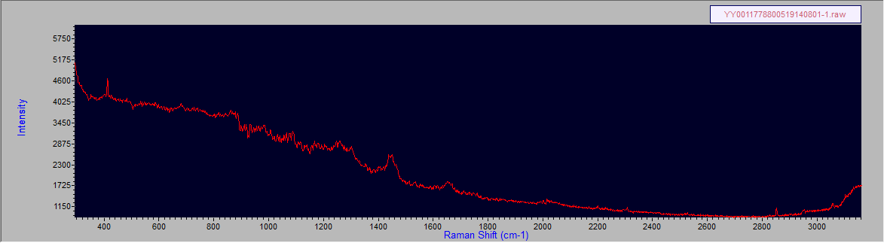

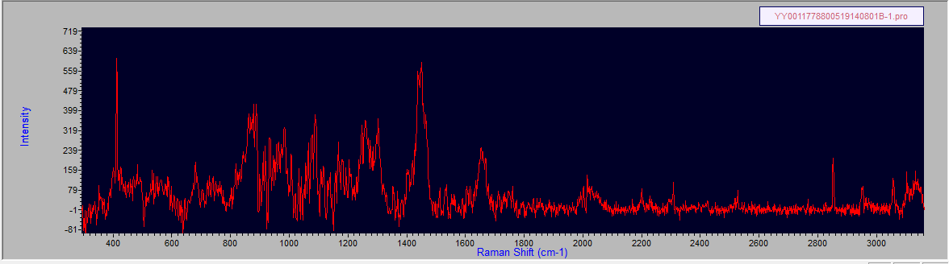

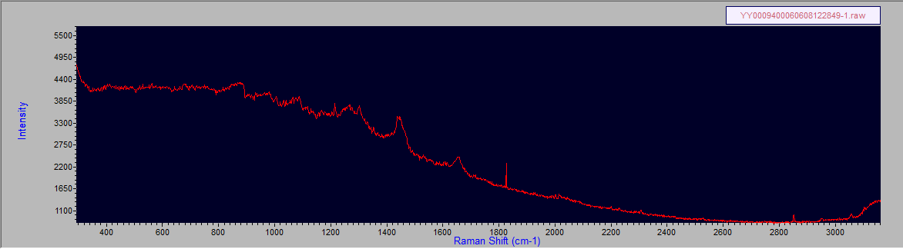

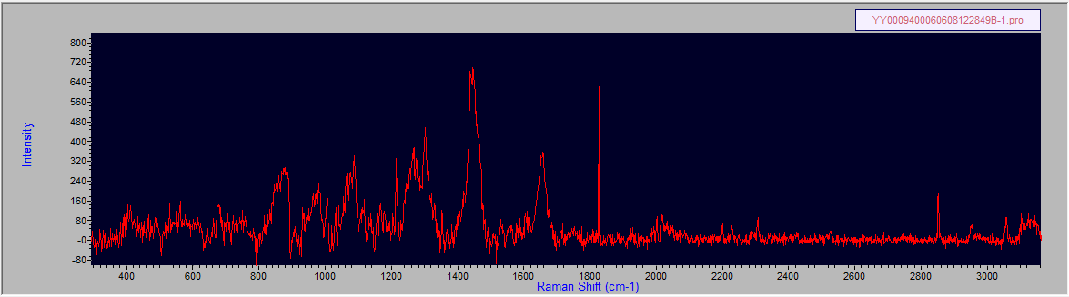

Neg

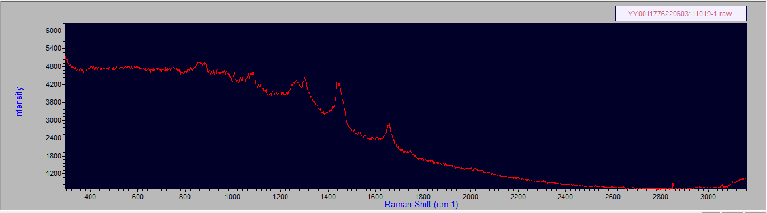

Neg

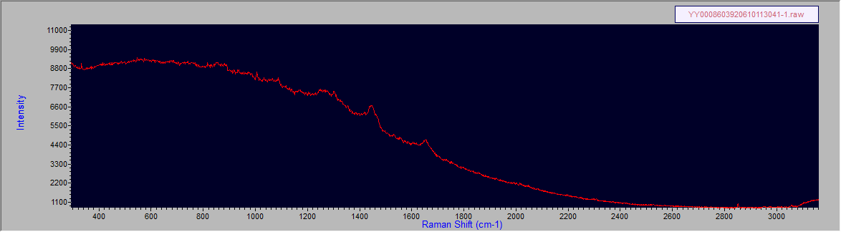

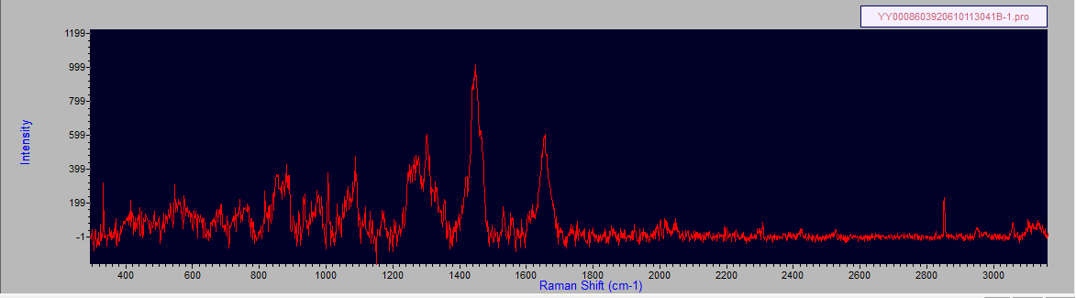

Neg

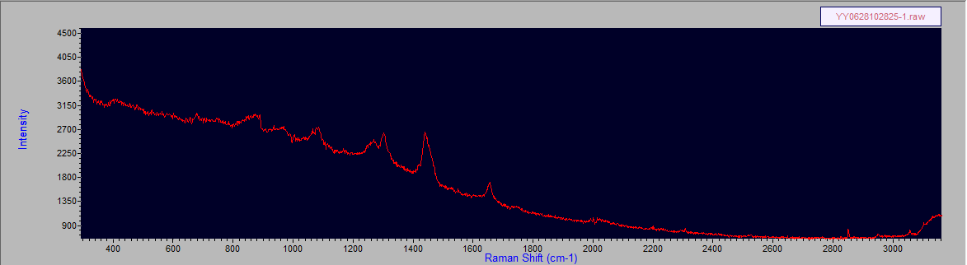

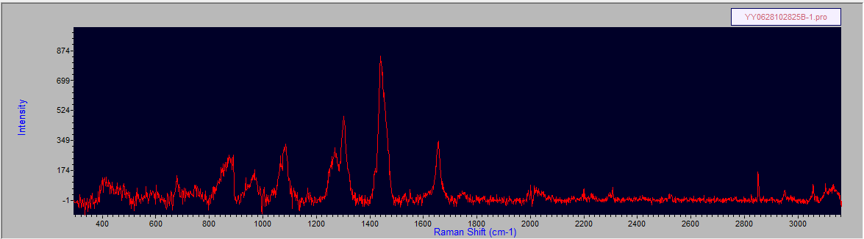

Neg

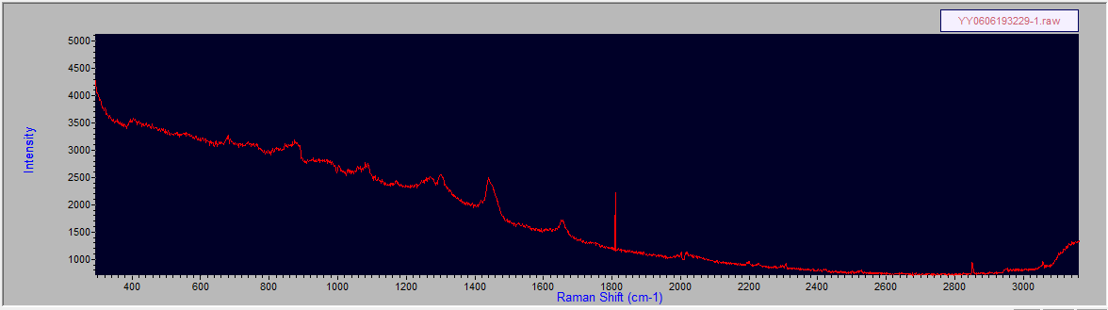

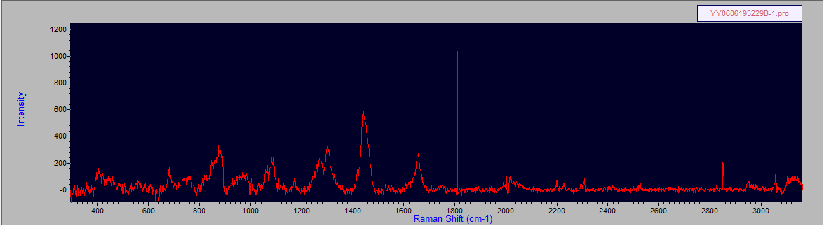

Pos

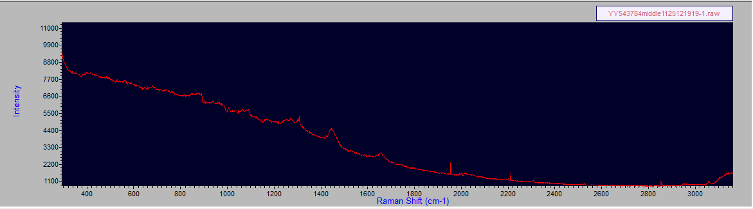

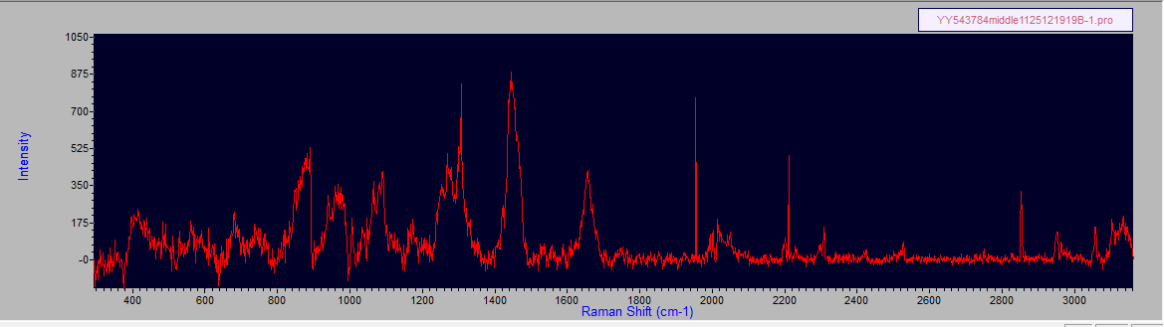

Pos

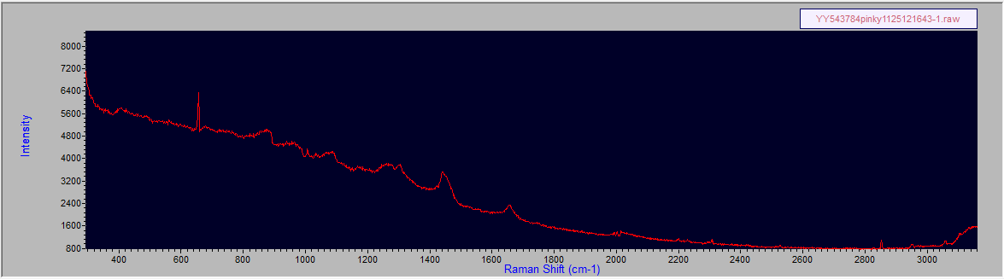

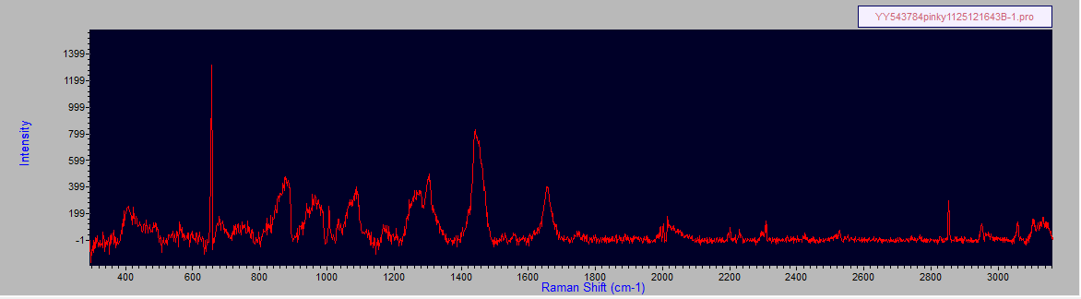

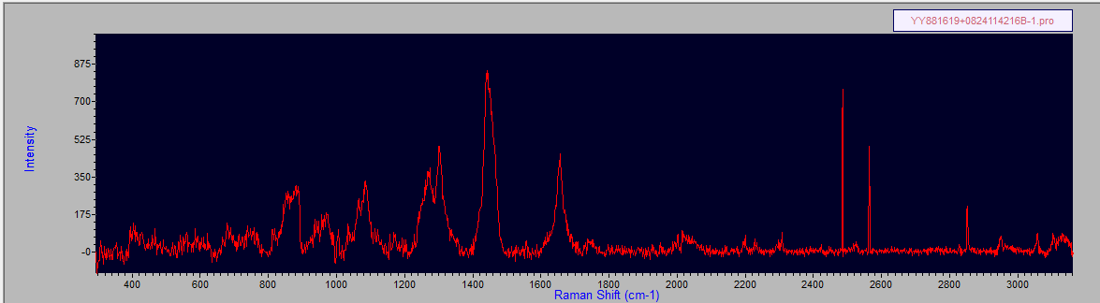

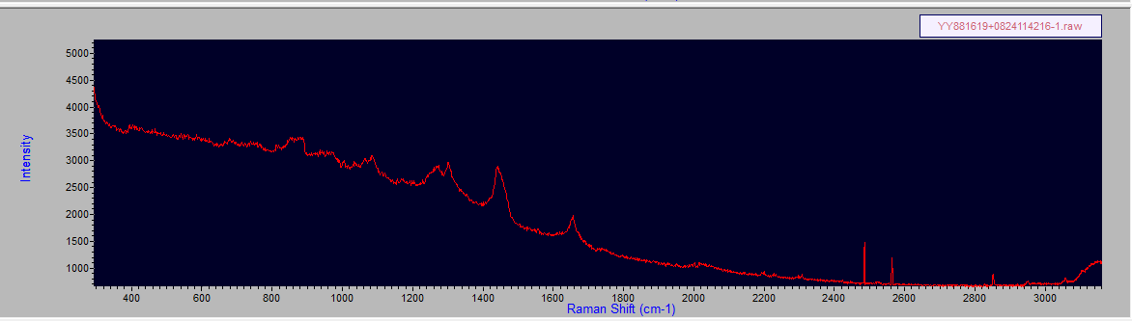

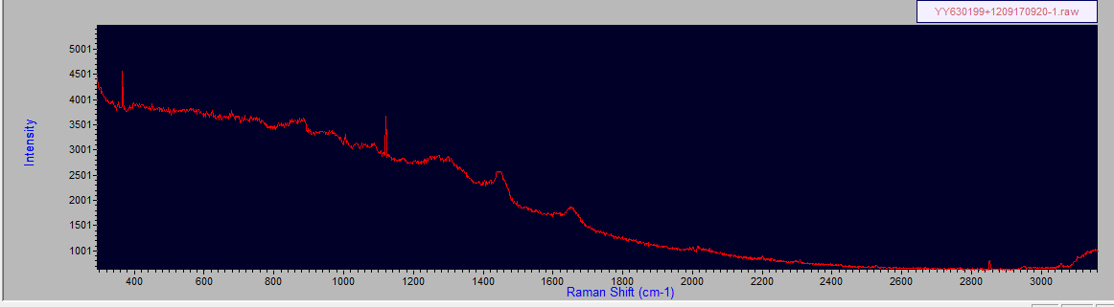

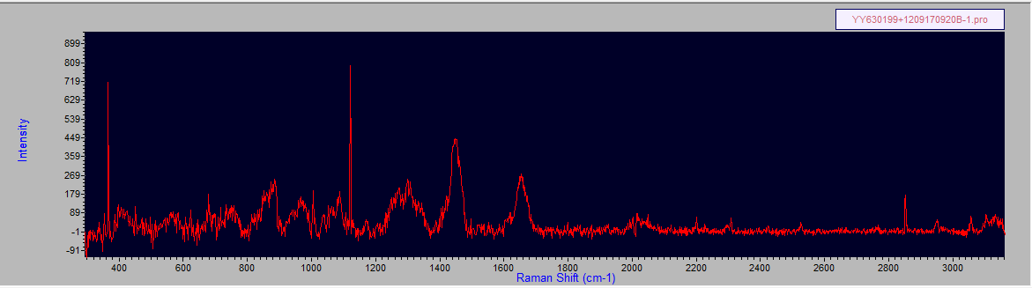

Neg

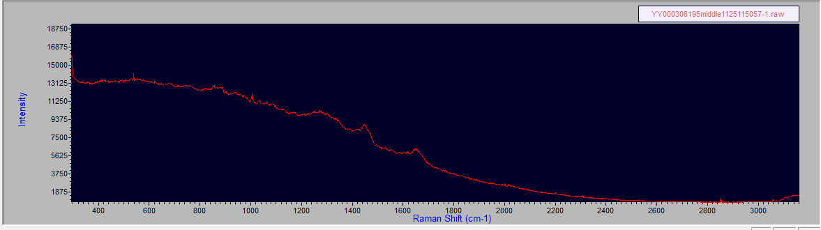

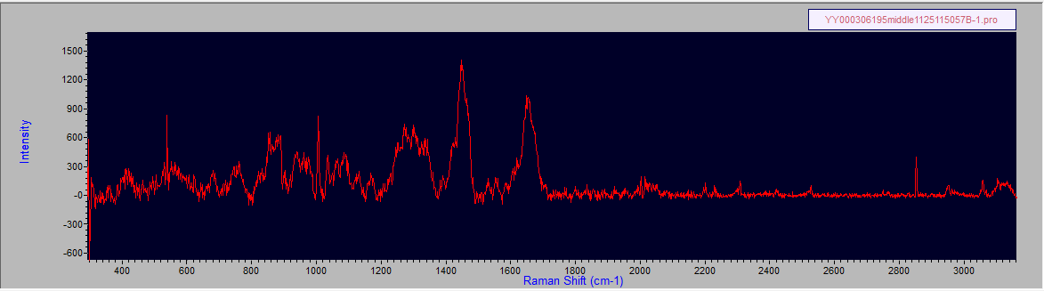

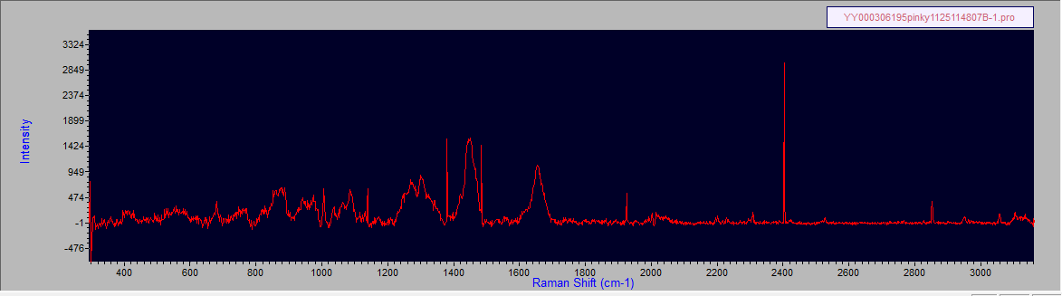

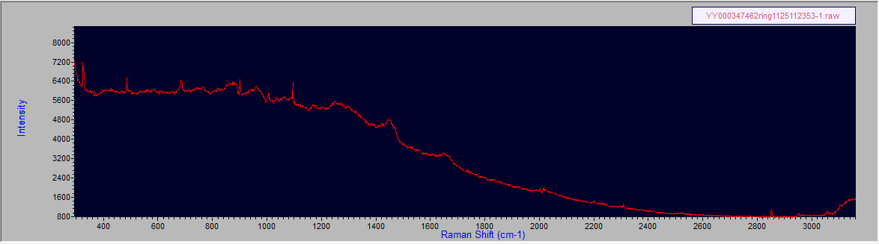

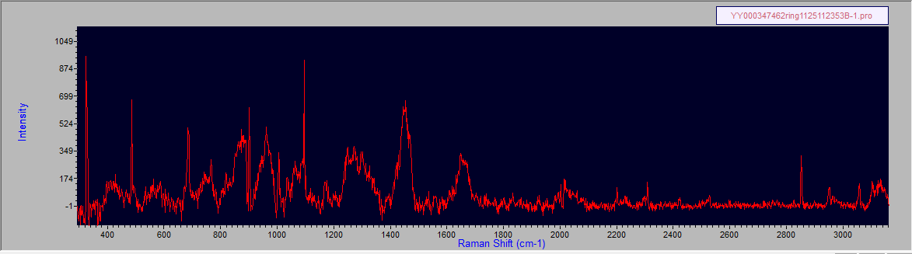

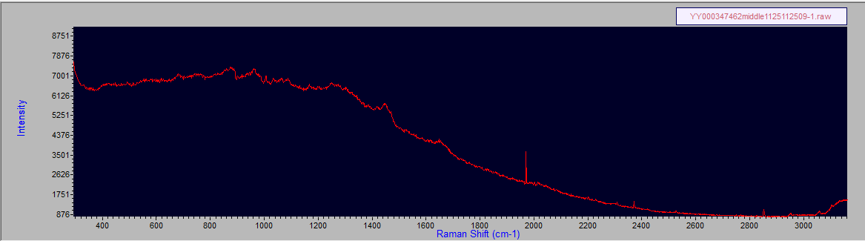

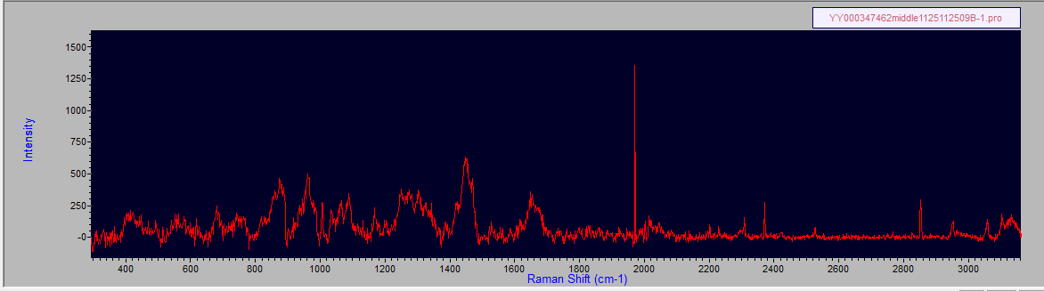

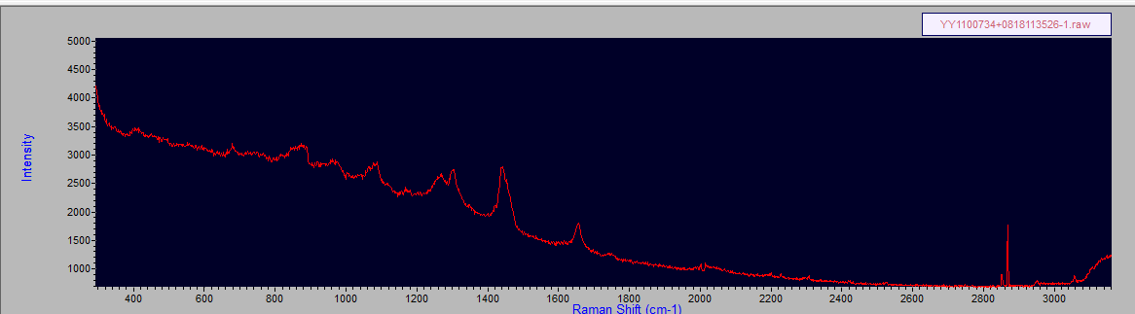

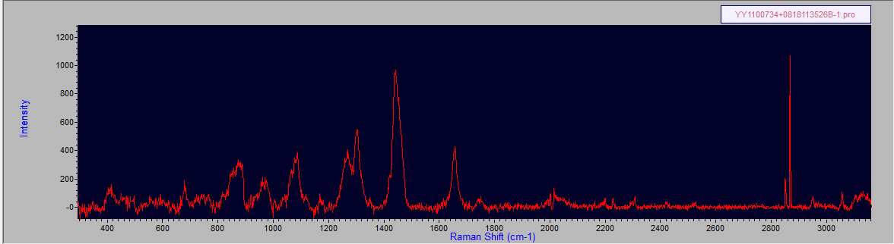

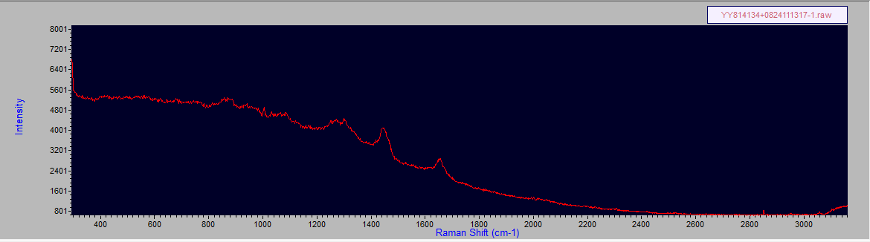

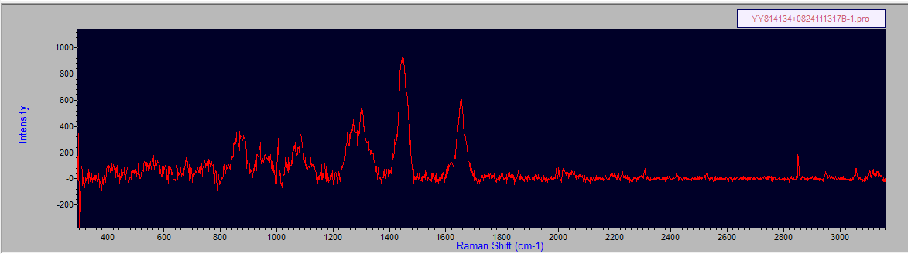

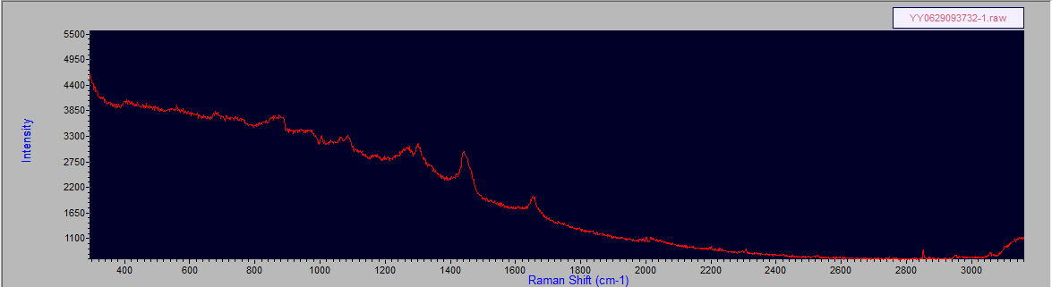

4 Neg

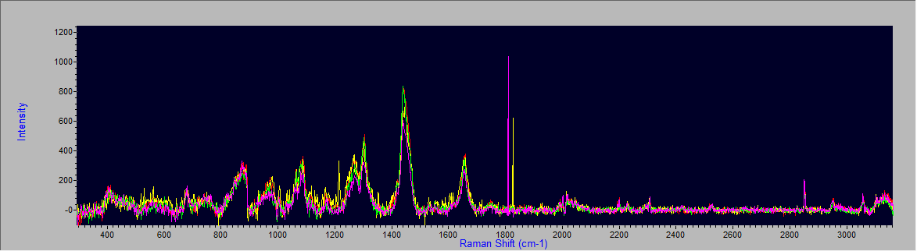

3 Neg

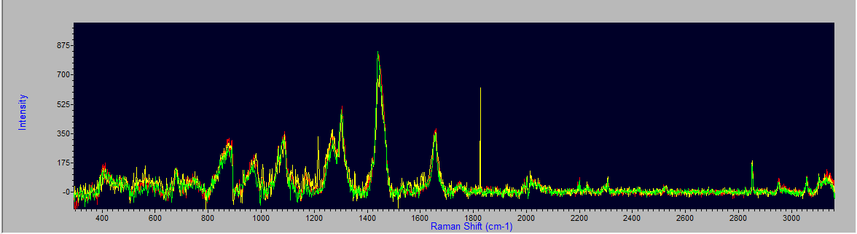

4 Pos

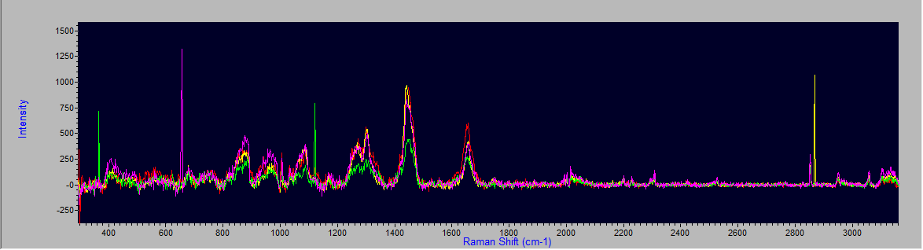

3 Pos

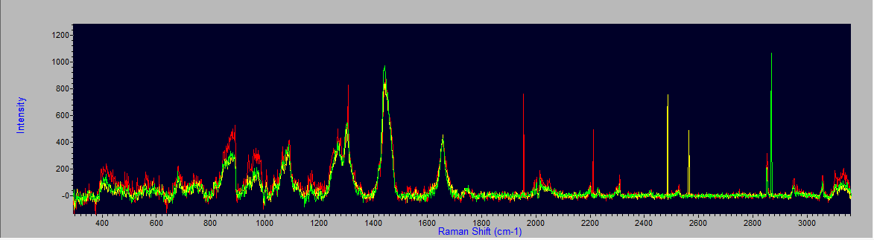

Pos(yellow and red) and Neg(green and purple)

